**USING RAPTOR –DISPLAY LENGTH OF STRING**

**FLOWCHART**

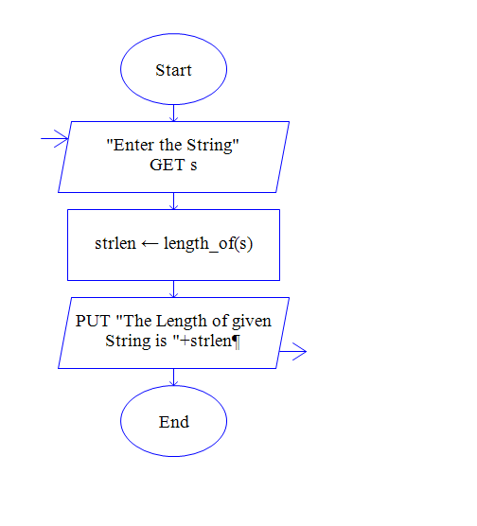

**INPUT**

**SAVEETHASCHOOLOF ENGINEERING**

**OUTPUT**

